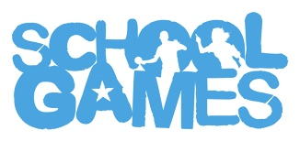

School Games National Santa Dash 2020!
Friday 11th December 2020
This is a national event taking place simultaneously all over the country!
We will be doing the Santa Dash - just seven laps of the cycle track.
It’s a whole school event, all you need to take part is a Christmas jumper, a festive hat, some comfy trainers and plenty of festive cheer.
Donations of £1 to take part in exchange for a raffle ticket for the chance to win a prize!!!!!!
Certificates for participation and DOJO points throughout the event.
Parents please send in £1 via ParentPay
